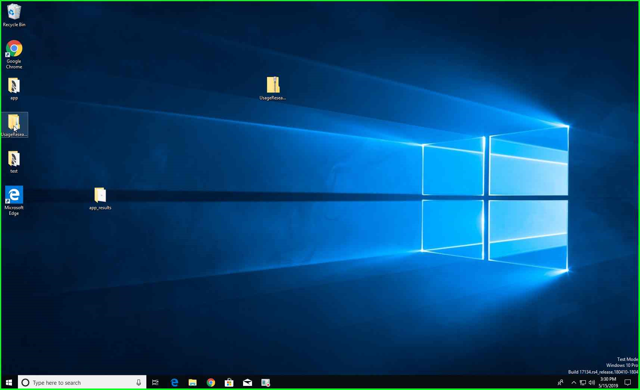

Step 1: To uninstall all the tools, open the UsageResearch folder

”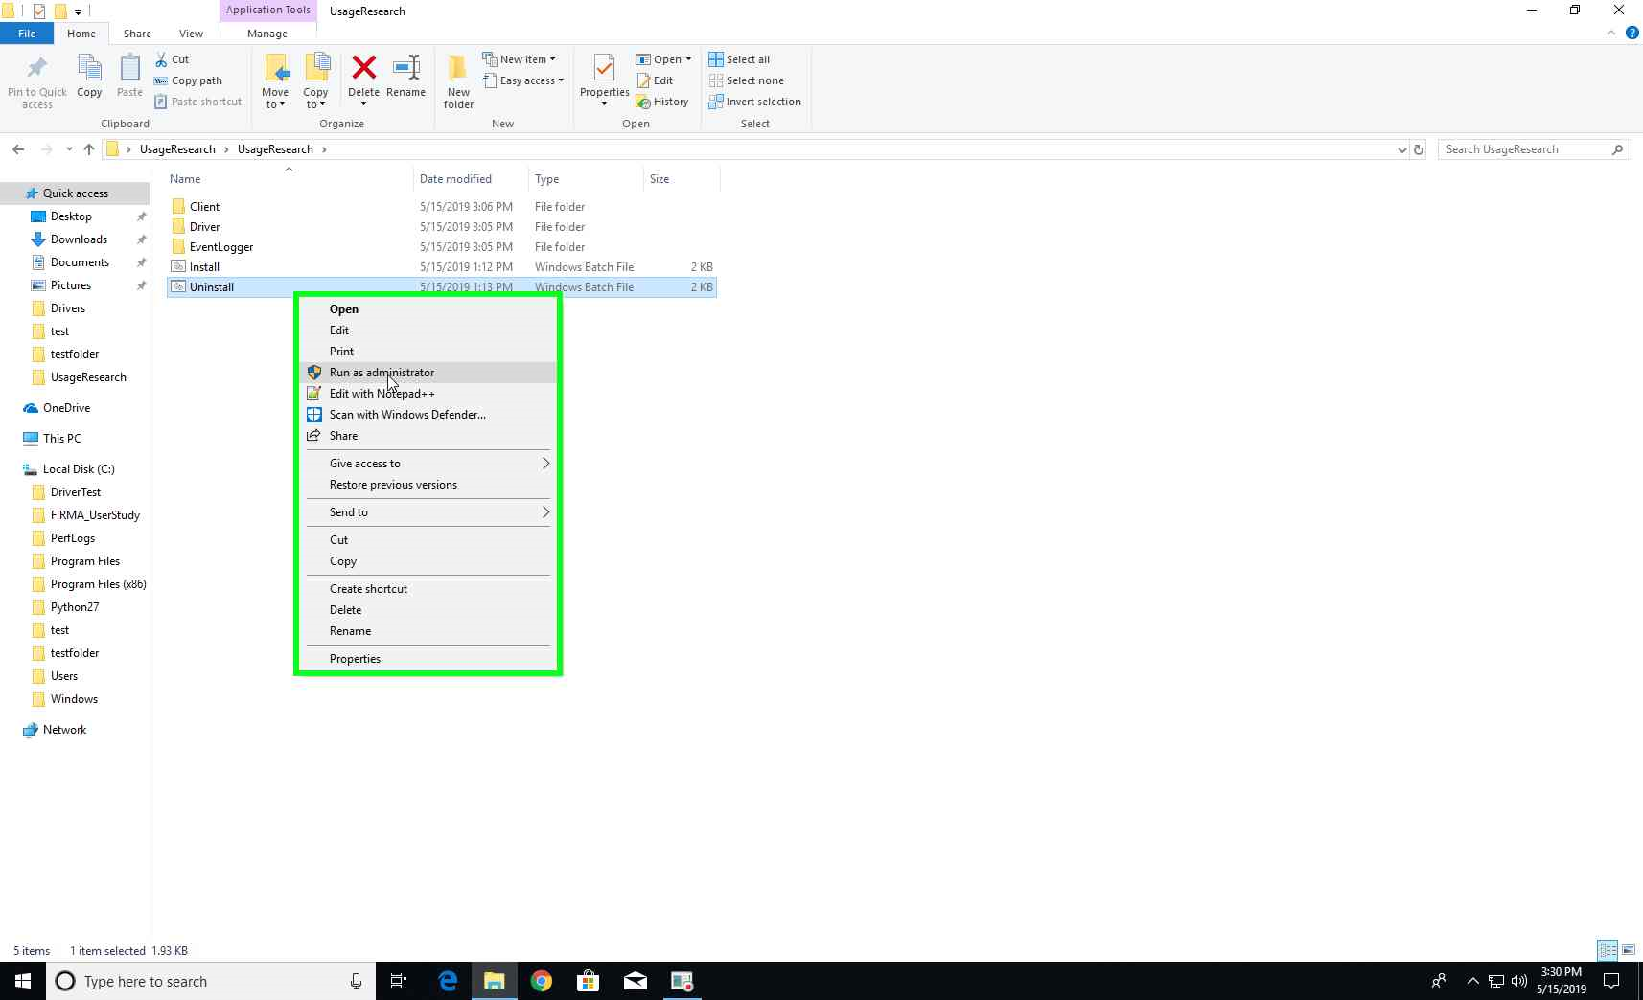

Step 2: Right-click on Uninstall.bat and select “Run as Administrator”

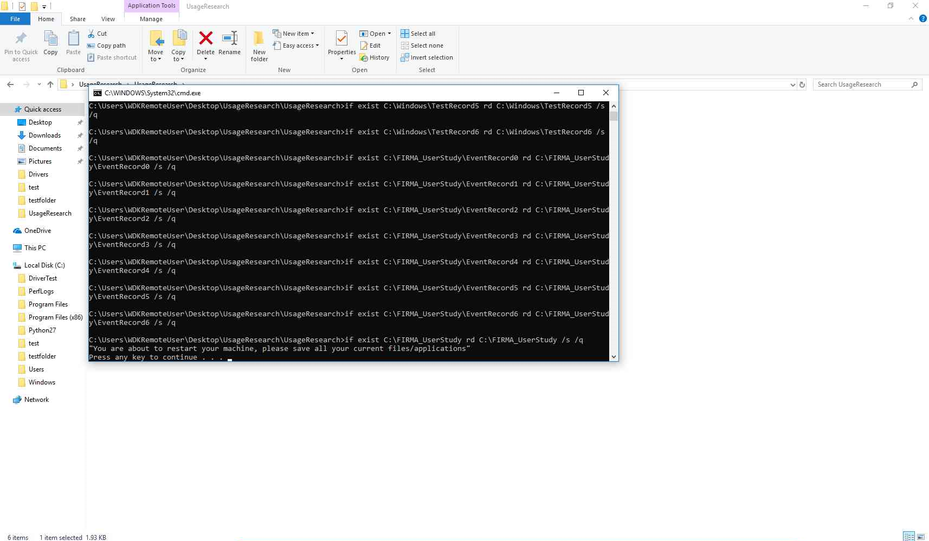

Step 3: All tools are uninstalled. Press enter to exit. The system goes for a reboot.